***Smart parking***

***Team Members:***

* ***R. ARUNKUMAR***
* ***C. PRASANNAKUMAR***
* ***A. SHIVAS***
* ***V. N. DEVA***
* ***R.NARESH***

***Project Title:*** *Smart Parking*

***Project steps:***

***Phase 1:*** *project definition and design thinking*

***project definition:***

* *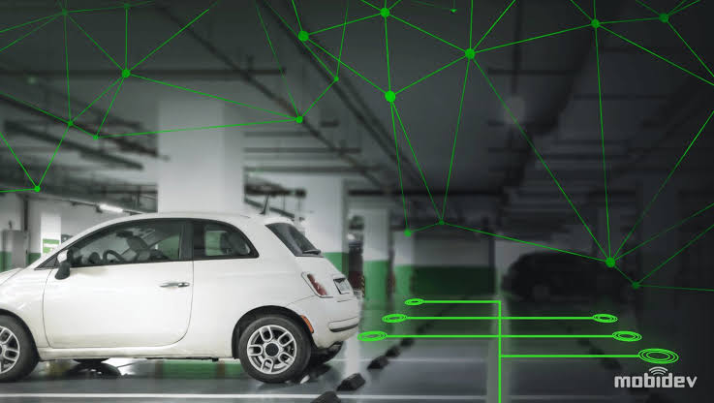Smart parking refers to the use of technology and data to improve the efficiency and convenience of parking management. It typically involves the use of sensors, cameras, and mobile apps to provide real-time information about parking availability, help drivers find parking spaces more easily, and optimize parking space usage. Smart parking systems can reduce congestion, save time and fuel, and enhance the overall parking experience for both drivers and parking facility operators.*
* *Smart parking systems can be categorized into several types, each offering different features and technologies to make parking more efficient and convenient. Here are some common types of smart parking systems:*

***1.Sensor-Based Smart Parking:***

*This type uses sensors (such as ultrasonic, infrared, or camera-based) to detect the presence or absence of vehicles in parking spaces.*

*Real-time data is collected and used to guide drivers to available parking spots through mobile apps or digital signage.*

***2.IoT-Based Smart Parking:***

*Internet of Things (IoT) technology is used to connect parking infrastructure, sensors, and vehicles.*

*Information is transmitted via the internet, enabling real-time monitoring and management of parking spaces.*

***3.Mobile App-Based Smart Parking:***

*Smartphone apps provide real-time information about available parking spaces.*

*Users can reserve and pay for parking spots through the app, making the process more convenient****.***

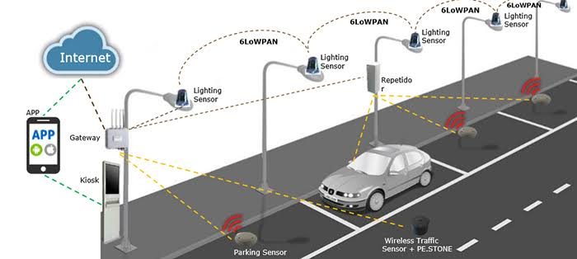

***4.License Plate Recognition (LPR) System:***

*Cameras capture license plate information to track entry and exit of vehicles.*

*LPR systems are often used for automated entry/exit, payments, and security****.***

***5.Automated Parking Systems:***

*Fully automated parking garages or structures that use robotics to park and retrieve vehicles.These systems maximize space efficiency and reduce the need for human attendants.*

***6.Payment and Access Control Systems:***

*These systems include automated ticket dispensers, payment kiosks, and access barriers (e.g., gates or bollards) that facilitate entry and exit.*

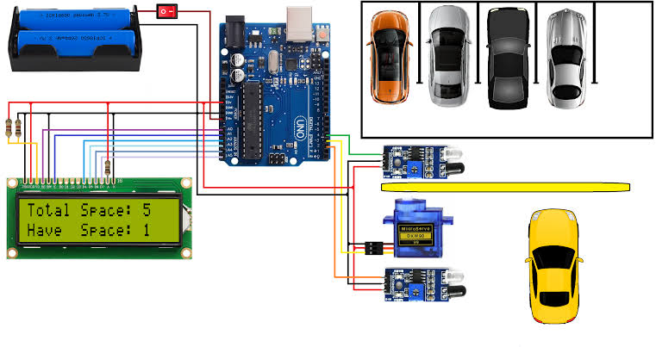

***7.Reservation-Based Smart Parking:***

*Drivers can reserve parking spaces in advance through websites or mobile apps.*

*Guarantees parking availability, especially during peak hours or special events.*

***8.Smart Parking Guidance Systems:***

*Digital signs and LED indicators guide drivers to available parking spaces.*

*Reducing search time and congestion in parking lots.*

***9.Electric Vehicle (EV) Charging Stations:***

*Smart parking can include EV charging stations with features like reservation, payment, and monitoring.*

***Design thinking:***

Design thinking applied to smart parking involves a user-centered approach to creating parking solutions that are intuitive, efficient, and customer-friendly. Here's a design thinking process specifically tailored to smart parking:

**1.Empathize:**

Understand the parking ecosystem by conducting interviews, surveys, and observations with all stakeholders, including drivers, parking facility operators, and city planners.

Gather insights into the pain points and frustrations experienced by drivers when searching for parking.

***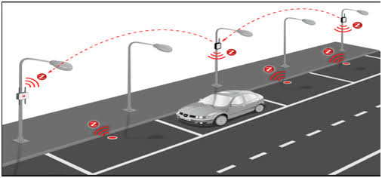*2.Define:**

Identify and define the core problems and challenges associated with parking.

Create a user-centric problem statement, such as "How might we reduce the time and stress drivers experience when searching for parking spaces in crowded urban areas?"

**3.Ideate:**

Brainstorm creative ideas and solutions to address the defined problems.

Encourage cross-functional collaboration to generate diverse ideas.

Explore innovative technologies and approaches to improve parking experiences.

**4.Prototype:**

Develop low-fidelity prototypes of potential smart parking solutions.

These prototypes can include user interfaces for mobile apps, sensor configurations, signage designs, and more.

Test these prototypes with real users to gather feedback on usability and effectiveness.

**5.Test:**

Conduct user testing with prototypes to gain insights into how users interact with the proposed smart parking solutions.

Collect feedback on ease of use, efficiency, and overall user satisfaction.

Iterate on the designs based on the test results.

**6.Implement:**

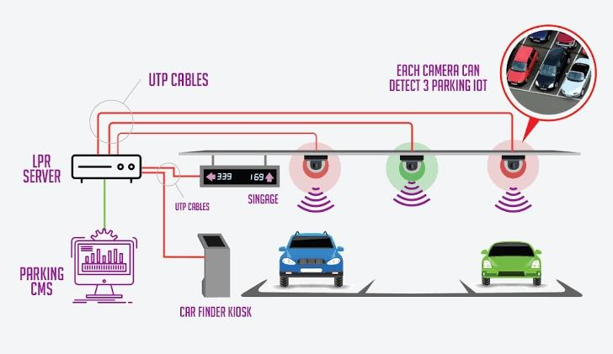Develop a detailed plan for implementing the smart parking system, considering technology, infrastructure, and budget constraints.

Collaborate with technology providers, municipalities, and parking facility operators to bring the solution to life

**7.Evaluate:**

After implementation, continuously monitor and evaluate the smart parking system's performance.

Collect data on parking occupancy, user adoption, and customer satisfaction.

Use this data to make improvements and adjustments as needed.

Throughout the design thinking process for smart parking, it's crucial to keep the focus on enhancing the user experience, reducing congestion, and optimizing the utilization of parking spaces. Additionally, collaboration among various stakeholders is key to ensuring that the final solution aligns with the needs and goals of all parties involved in the parking ecosystem.